Women's Healthcare Associates
Teams Voice Guide
A resource for the transition from SHoretel to teams voice

Contents
Making Calls 4
Physical Phone 4
Teams Desktop App 4
Physical Phone Log In 5
View Call History 7
Transferring and Other Call Actions 8
Consult then Transfer 9
Hold 9
Add a Contact 0
Teams Desktop App 0
Classic Teams 0
New Teams 3
Outlook Desktop App 4
Outlook on the Web 4
Set work hours and locations in Outlook 6
Outlook Desktop App 6
Outlook on the Web 7
How to Call Outbound Using Teams Mobile 8
Android – Managing Inbound Call Settings 11
Android - Turning on Notifications 12
iOS - How to Manage Inbound Teams Voice Settings 15
Call Queues 19
Vocabulary 19
View your Call Queues 19
Call Queue Names 20
Change Your Availability 22
Voicemails 23
Settings 23
Voicemail greeting 23
Set your call answering rules 23
Personal 24
Call Queues 25
Teams 25
Outlook 26
Suggested Voicemail Management Workflow 26

Making Calls
The transition from ShoreTel to Teams voice has phased out 4-digit extensions. You will now search by name of the call queue or person you are trying to reach.

Physical Phone
- Once you are logged into your phone, you can use the dial pad as normal! However, you do not need to dial 9 for external numbers!

Teams Desktop App
- The dial pad can be used like a typical phone to make a call to a phone number. (You can also type in names or groups.)
- To dial a number from Teams, go to Calls , and then enter the number of the person you want to reach by using the dial pad located on the left. Then click Call .
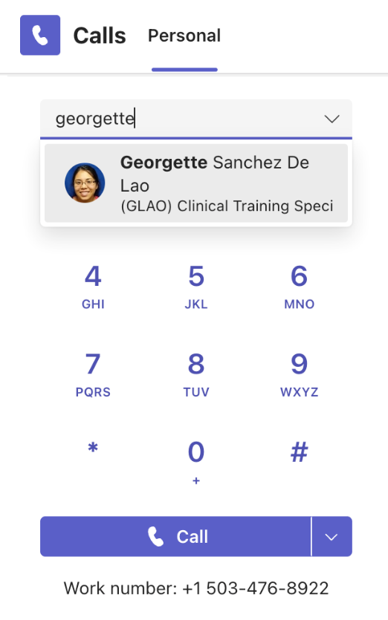
- To call a person by name, type the name of a person into the dial pad. And to make group calls, enter multiple names and/or numbers, and click Call .

Your work number is visible underneath your dial pad for easy reference!

Physical Phone Log In
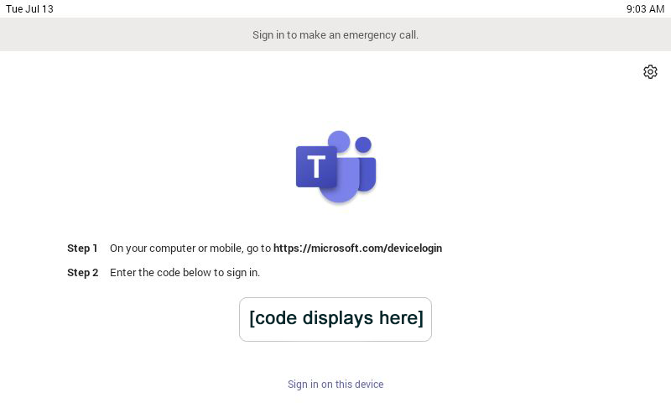
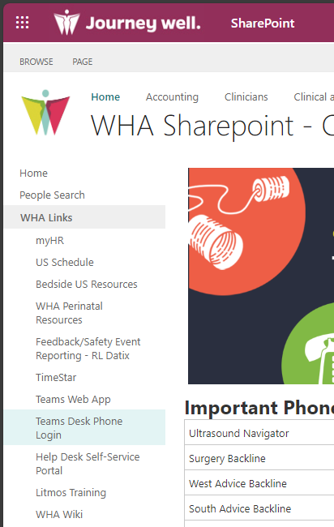
- On your computer or mobile device, go to https://microsoft.com/devicelogin or from SharePoint, under the WHA Links section.
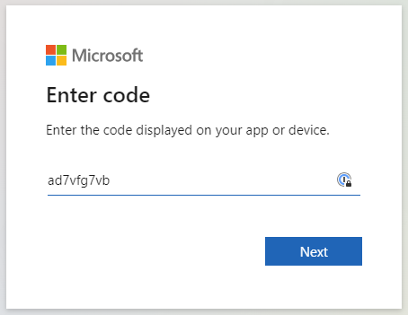
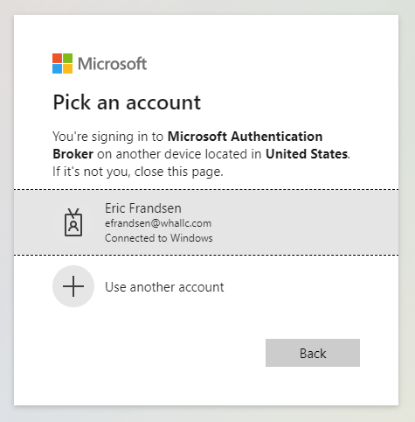
- Enter the code displayed on your Yealink desktop phone to sign in. Once you’ve entered the code, you will be presented with a page to enter your email address or select the account you are signing in with.

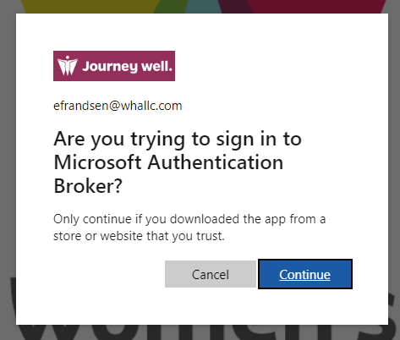
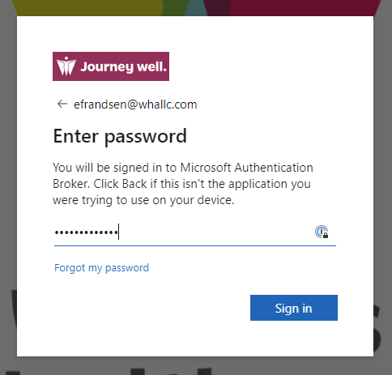
- You will be prompted to enter your password and click sign in. Click continue when prompted to confirm that you are trying to sign in to Microsoft Authentication Broker.

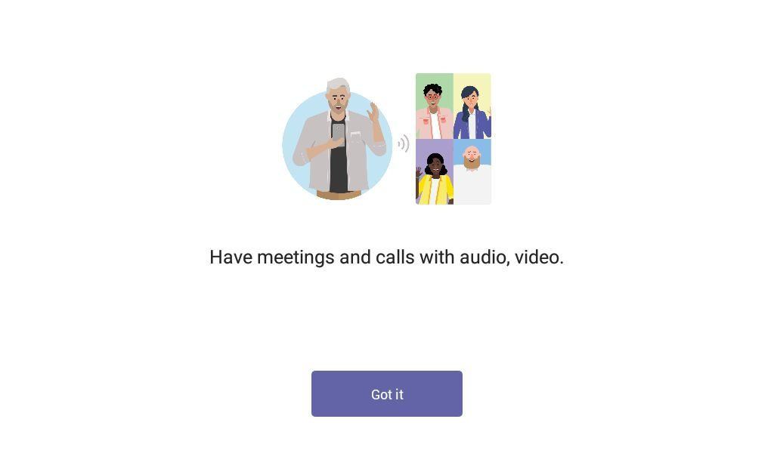
- Once you have signed in, your phone will automatically sign into your Teams account. Press Got It on your phone to start making and receiving calls!
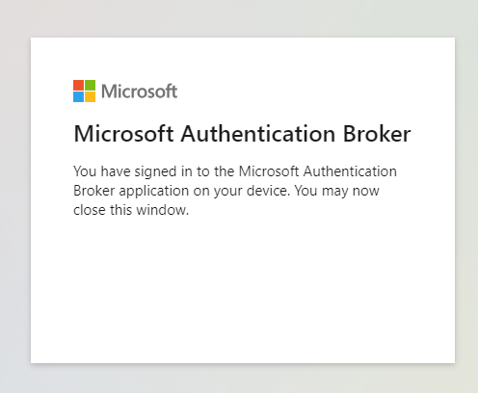

View Call History
Your call history is located in the center of the calls experience and shows a list of past calls (including missed calls).
- Go to Calls > History. From any call in the list, select More actions > Call back to begin a call automatically.
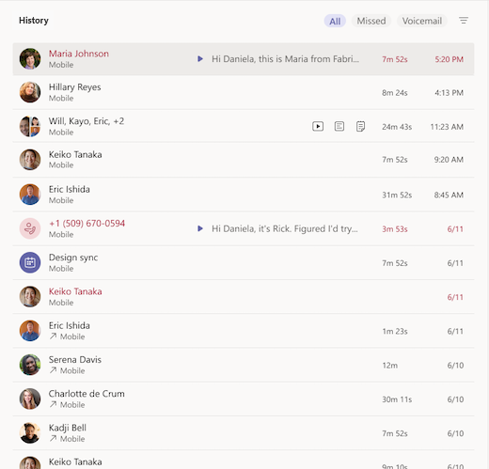
- You can also chat with that contact, add them to speed dial, and add them to your contacts—all from the More actions menu.


- To review a list of calls you’ve missed, lists of calls that came in, and your voicemail, select between the available filters at the top of the call history list.

Transferring Calls
  - When doing a “Cold Transfer” (no consult) from Teams to Five9, you can just initiate the transfer as normal.
- When you're in a call, select More actions > Transfer in your call controls.
- Start typing the name of the person you want to transfer the call to and select them when they appear.
- If they're in your org and using Teams, turn on Ring back if there's no answer to send the call back to you if the recipient doesn't answer or has call forwarding set.
- Select Transfer to complete the transfer or the dropdown arrow to choose Transfer or Consult then transfer.
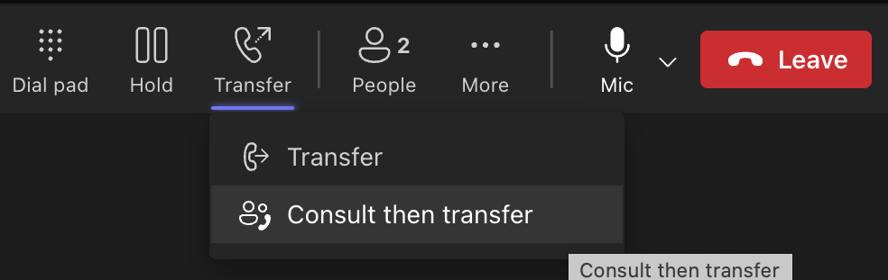

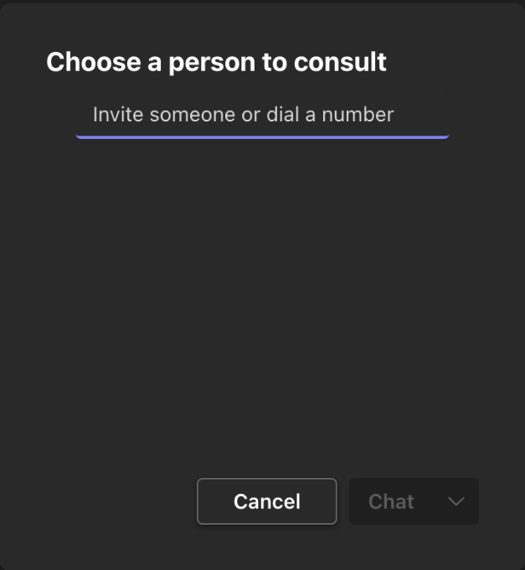
Consult then Transfer (Teams to Teams/External)
- When you're in a call, select More actions > Consult then transfer.
- Under Choose a person to consult, start typing the name of the person you want to reach and select them when they appear.
- Consult with them by calling or using chat.
- When you're ready, hit Transfer.

Consult then Transfer (Teams to Five9)
- When you're in a call, select More actions > Consult then transfer.
- Select the Five9 Skill/Campaign FWD account you want to call and wait for it to connect. At this point, the other caller will be on hold.
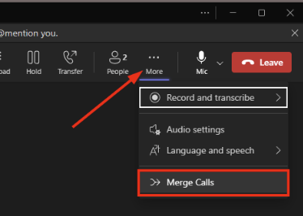
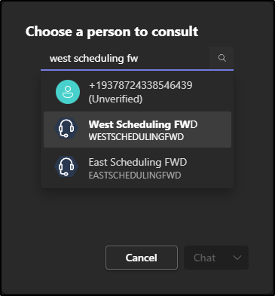
- Once you have completed your consult with the Five9 agent and are ready to transfer the other party, select …More > Merge Calls
- Confirm the external party and click Merge
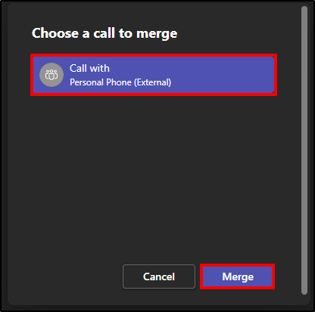
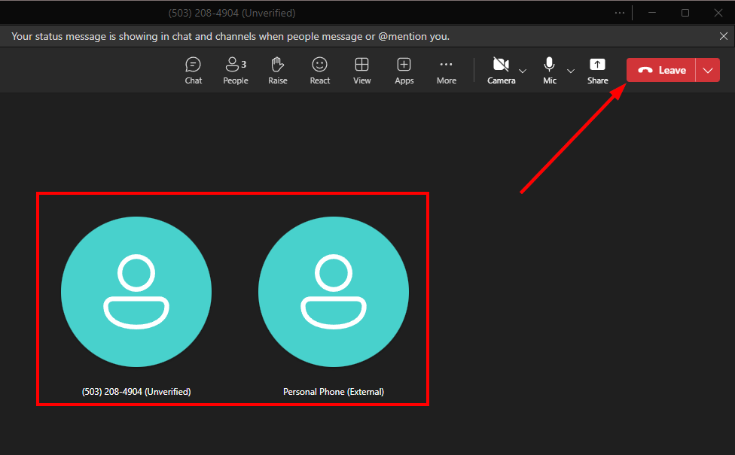
- Once you see the “circles” for both parties, click Leave to disconnect yourself and leave them connected to each other.

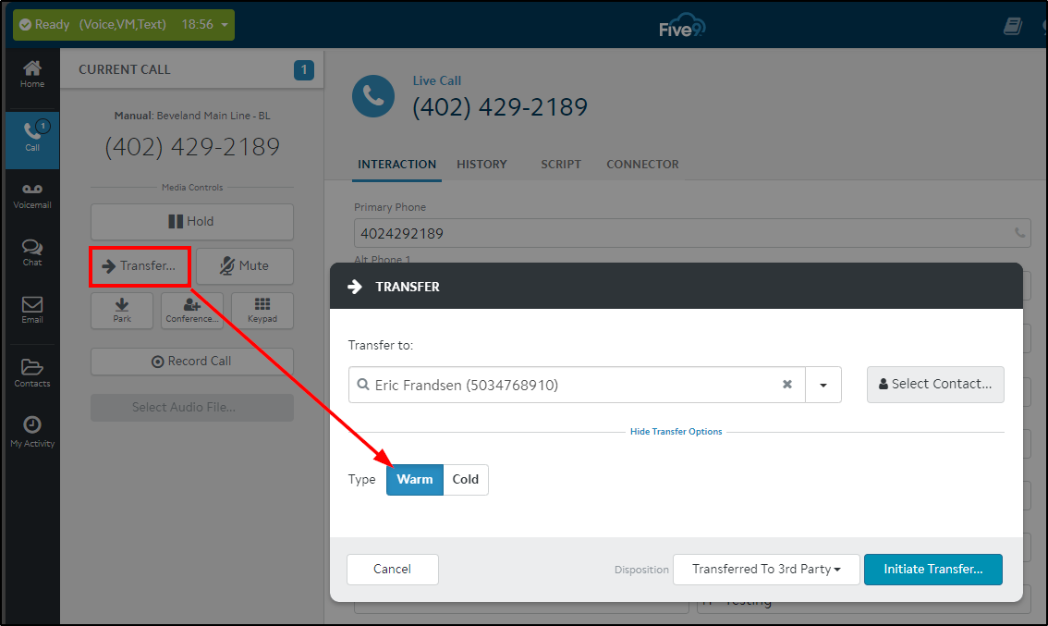
NOTE: Consults from the other direction (Five9 to Teams) don’t require a special workflow – you can just do a Five9 Warm Transfer as normal

Place Calls on Hold
- To place a call on hold, select Hold at the top of your call window. You won't see this option if you're in a scheduled Teams meeting.
- Everyone on the call will be notified that they've been put on hold, and you can continue your call by selecting Resume.
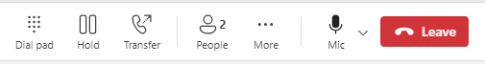
- People on hold (including you) won't be able to see or hear anyone else on the call. Screen sharing is temporarily suspended, too. Everything will return to normal once you resume your call

Conference/Add a Someone to a Call
  - When you're already on a call, you might want to add someone new and create a group call.
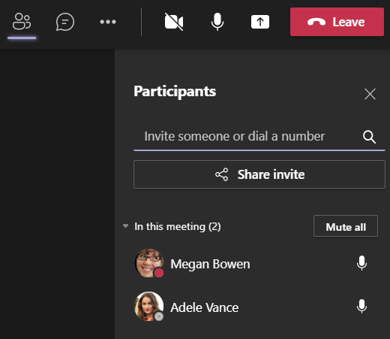
To add someone new to a group call, select Show participants in your call controls, then type their name or phone number in the search box.

Add a Contact

Teams Desktop App

Classic Teams
To view your Teams contacts, select Calls and choose Contacts on the left. Here you'll find an A-Z list of all your contacts and a search bar that you can use to find someone specific.
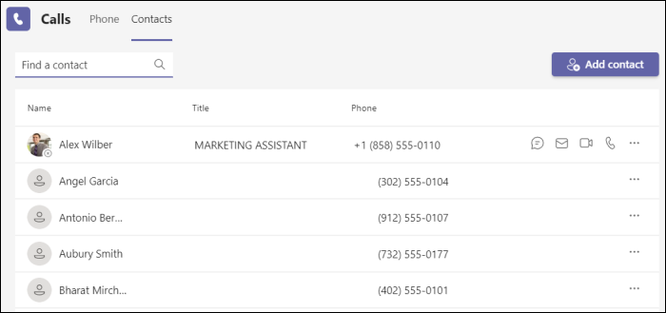
If you want to add a new contact to your list, click Add contact at the top of your list to get started.
You can also access your Speed dial contacts and any call groups you have created—all on the right side of Teams. Just select Calls and access them there at any time.

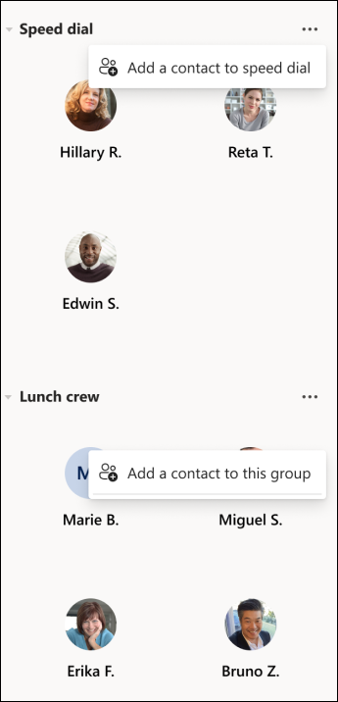
Things you can do from here:
- Speed dial allows you to quickly reference and call back any recent contacts or contacts that you have added to speed dial.
- Call groups organize your teammates to help you find or reach certain people based on a role or team.
- To add someone to speed dial or any call group, select More actions next to the group name and choose Add a contact to this group.
- You can quickly call any contact back by selecting Call below their name.

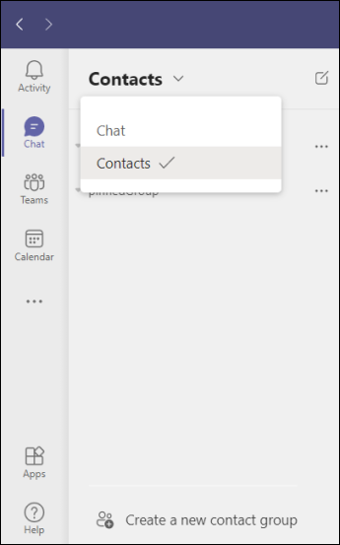
To create a new contact group, first go to Chat on the left side of Teams. Then select the Chat dropdown at the top and select Contacts.

Next, choose Create a new contact group at the bottom. Then follow the instructions to create a new group.
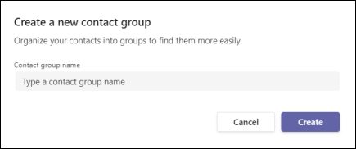

New Teams
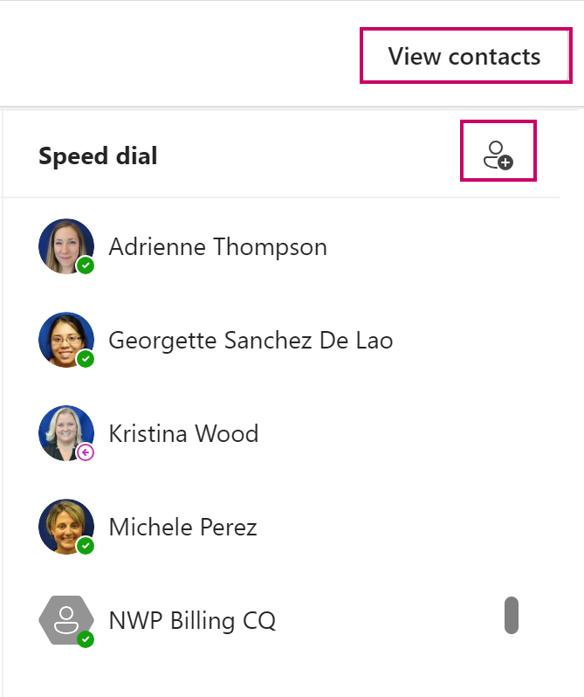
In the new Teams, contacts have been moved to the People app. If you do not have it pinned to your app list on the left side of Teams, you can find it from the Calls app. In the People app, you can add new contacts, designate contacts as favorites, and add categories to contacts.
- In Calls , select View contacts in the top right of Teams. This will open the People app. If it is not pinned, you can right click the app name to pin it.
- Select Add contact at the top to add new contacts. (This includes our call queues!)
- Type the person's name and select from the dropdown.
- The Add contact box will appear to allow you to edit their information. When done, select Save.
To edit a contact or add a category:
- Highlight the contact's name under All contacts.
- Select More . Selecting Add a category will allow you to create a category tag for that person or apply an existing category. You can find these groupings under Categories, which will appear on the left side under People.

Outlook Desktop App
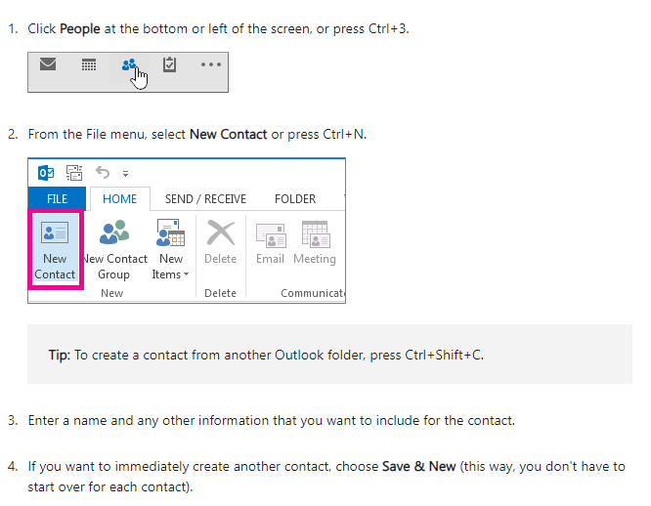


Outlook on the Web
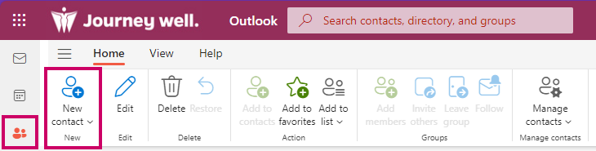
- Select People.
- Select New contact.
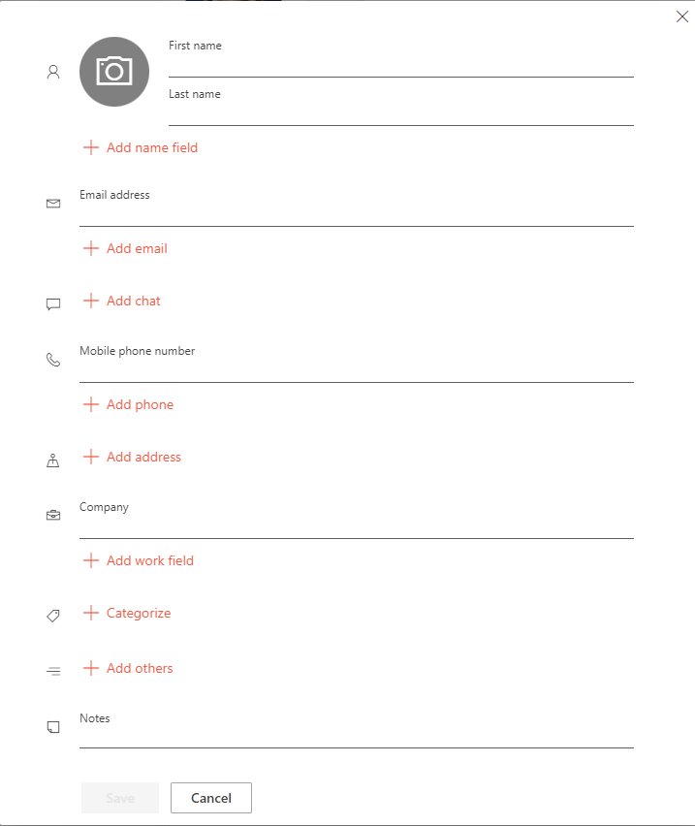
- Add contact details.
- Select Save to finish.

Set work hours and locations in Outlook

Outlook Desktop App
- Open Outlook and click on the Calendar icon at the bottom of the screen.
- If you want to change your work hours, click on the File tab, select Options.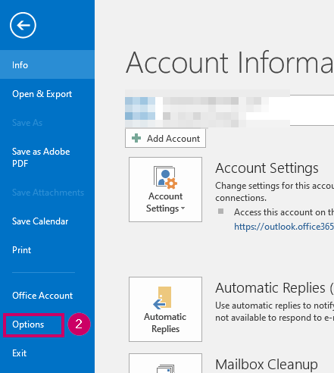
- Click on Calendar.
- Under Work time, you can choose the Start time and End time of your workday and select the days of the week that you work. Click on OK to save the settings.
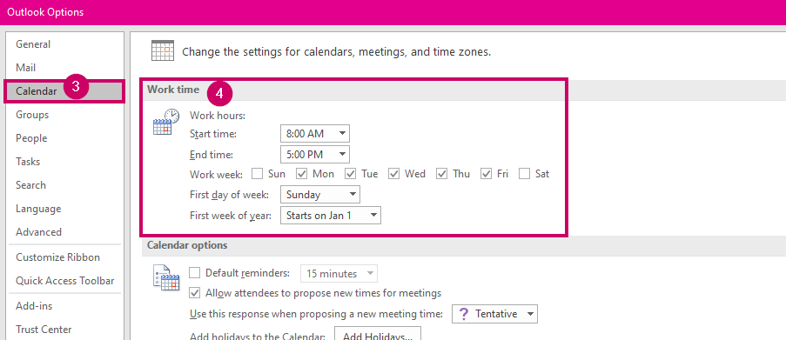

Outlook on the Web
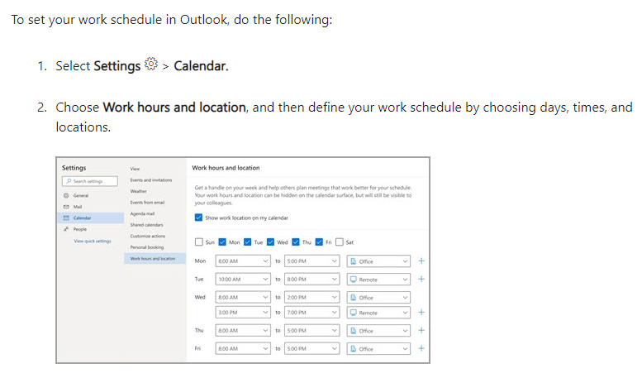

How to Call Outbound Using Teams Mobile
  - Calling outbound through the Teams mobile app allows you to use your phone for Teams calls without exposing your personal cell number.
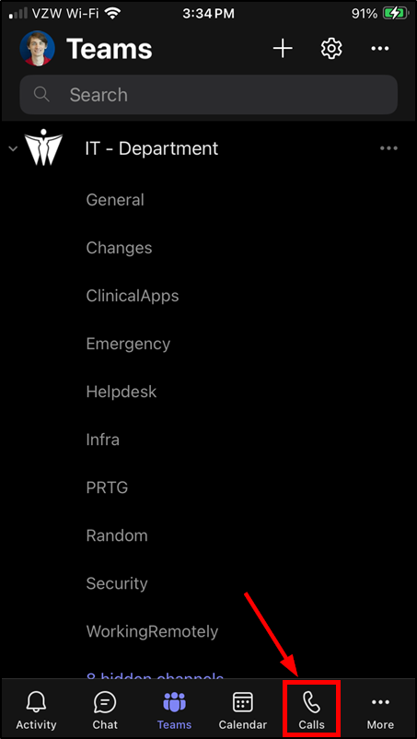
- From the bottom of Teams menu, select Calls

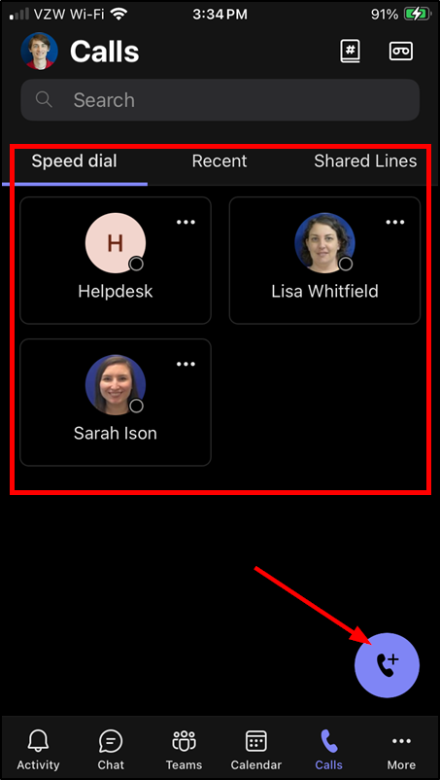
- Select a Speed Dial or Recent Call (not using Shared Lines) or press the phone+ button to dial manually.

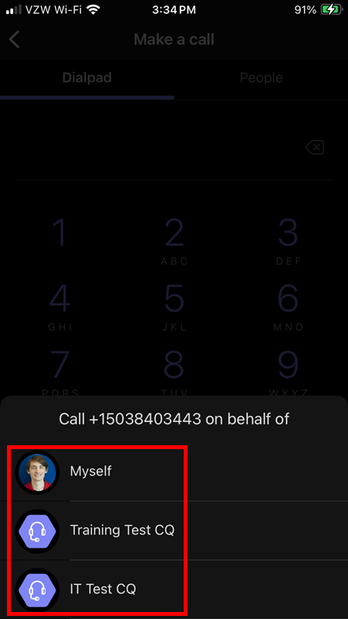
- Select whether you want the Caller ID to appear as coming from your WHA phone number (“myself”), or the Caller ID number for one of the Call Queues you’re a member of.

Android – Managing Inbound Call Settings
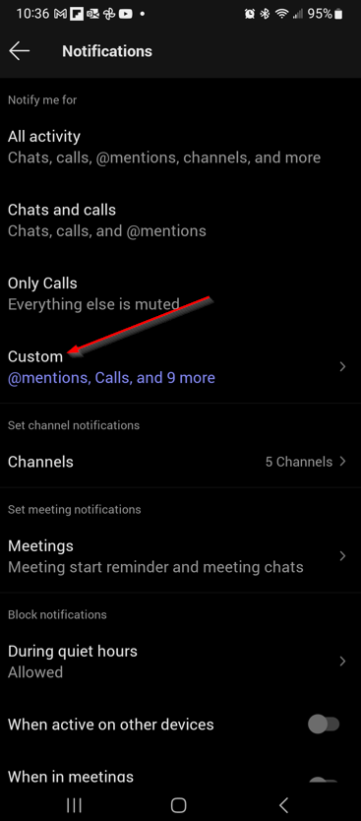
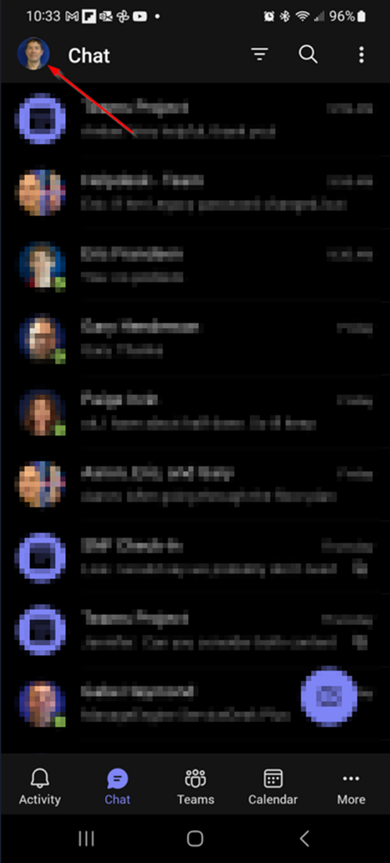
- Tap your picture in the top left corner.
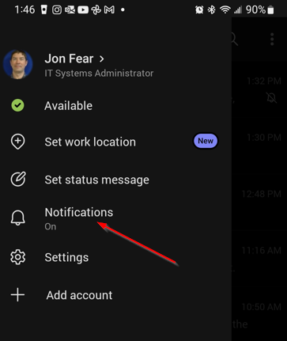
- Select Notifications and then select Custom.

Android - Turning on Notifications
- To access phone notification settings, slide down from the top to bring the Quick Settings menu, and then tap Settings cog.
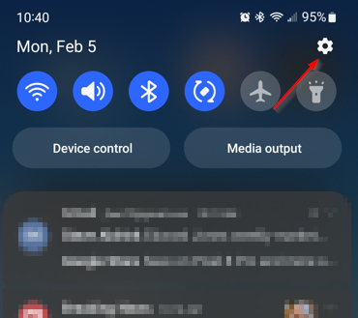
- Tap App Notifications, scroll down to find the Teams toggle switch and make sure it’s turned on:
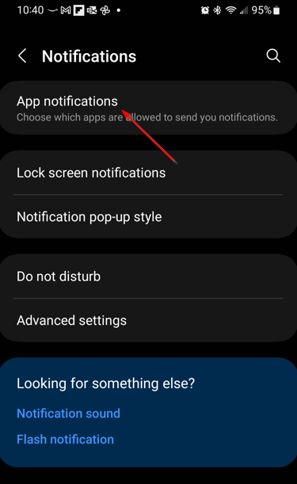
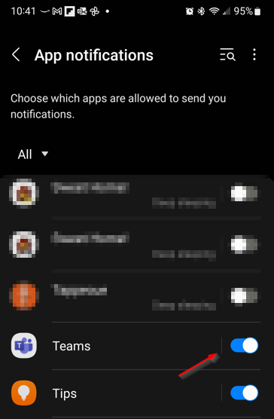

- From your settings, find the App Notifications category and find the Teams app.
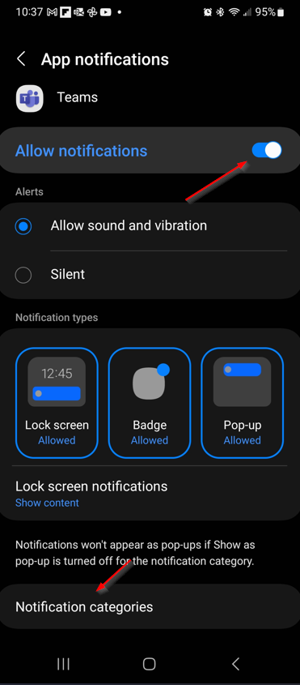
- Make sure that “Allow Notifications” is toggled on, and then tap “Notification Categories.”
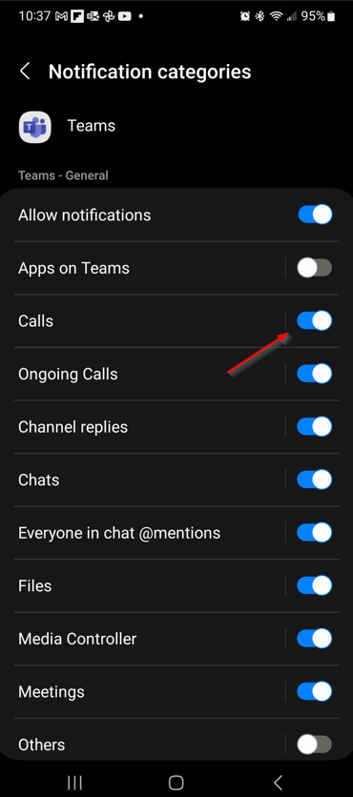
- Enable or disable call notifications by toggling the Calls switch.

iOS - How to Manage Inbound Teams Voice Settings
Note: Notifications must be enabled for Teams in iOS Settings before the options in the app are available.
- Select Settings and scroll down to Notifications.
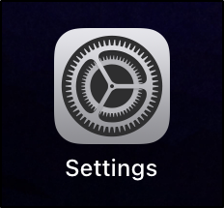
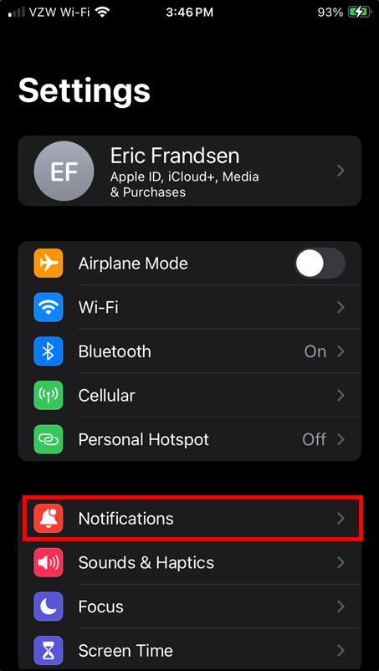

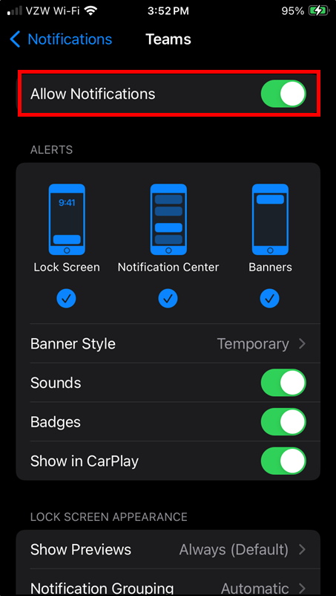
- Tap Teams and toggle on Allow Notifications.
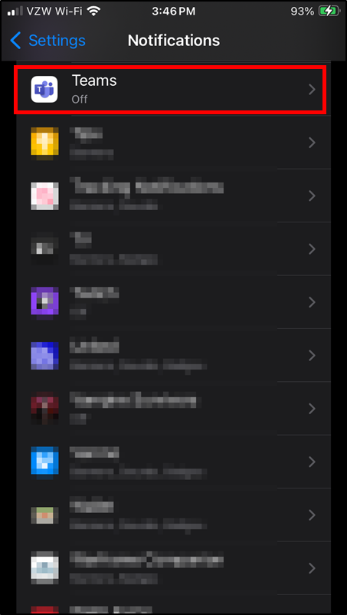

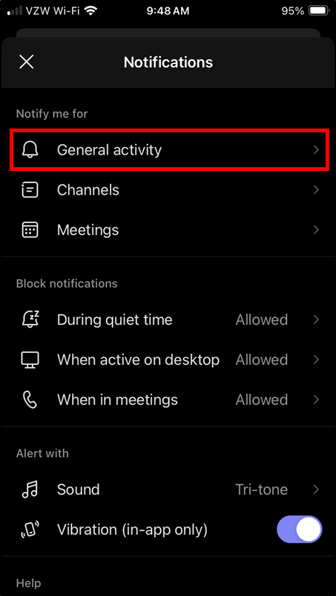
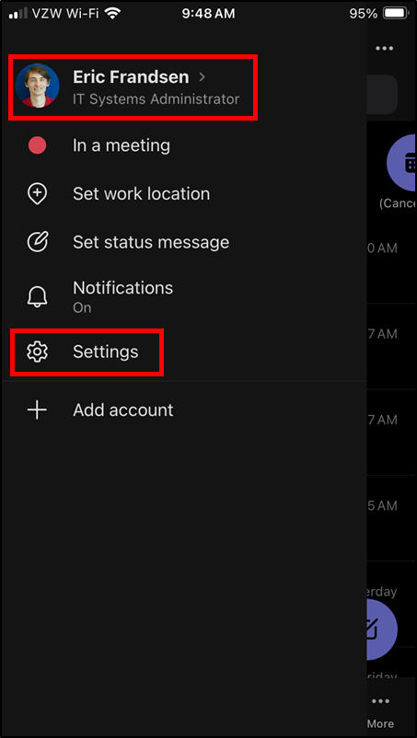
- In Teams, tap your photo in the upper-left corner and press Settings. Then select General Activity

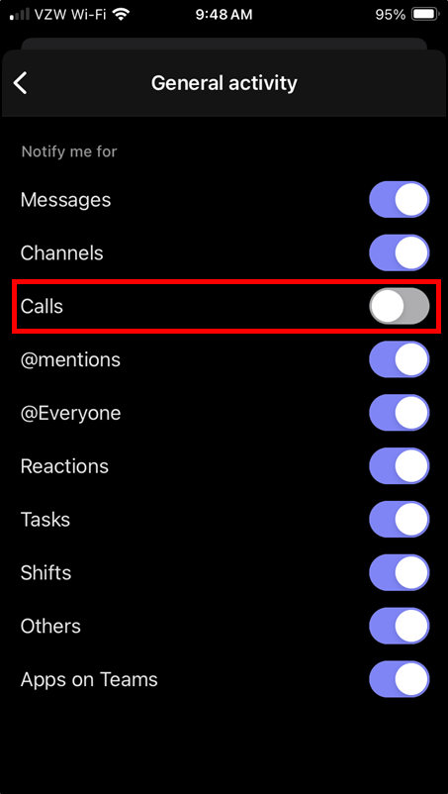
- Toggle calls on and off as needed!

Call Queues
  - A call queue replaces our ShoreTel work groups and hunt groups.

Vocabulary
- Call Queue (CQ): Replaces ShoreTel work groups and hunt groups.
- Auto Attendant (AA): The robot that transfers our calls to where they need to go!
- Forward (FWD): Forwards to Five9.

View your Call Queues
All call queues are attached to a channel in teams. You can find them by navigating to your teams within Teams.
- In the channel, select the Calls tab.
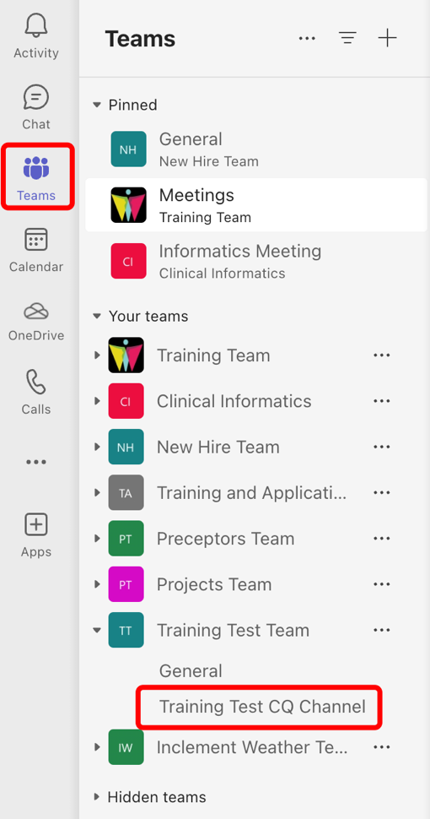
You'll see your individual agent call queue history and previews of your call queue's shared transcribed voicemail.
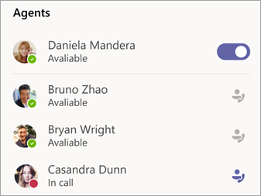
The Agents list in the lower right corner shows you who else is available to take calls.

Call Queue Names
Use this handy list if you are having a hard time searching for the correct phone line!
ShoreTel Name | ShoreTel Ext. | Teams Name
BL Billing WG | 3302 | BL Billing Intro AA
BL Central Lab HG | 1215 | BL Central Lab Intro AA
BL HIM Auditor VM WG | 3616 | BL HIM Intro AA
BL HIM WG | 3626 | BL HIM Intro AA
BL HR GDM | 3306 | BL HR GDM CQ
BL Imaging Specialist WG | 3242 | Mammo Imaging Specialist CQ
BL Operator WG | 3301 | BL Operator CQ
BR Backline HG | 4802 | BR Backline CQ
Coding Internal-Only Support WG | 3291 | Coding Internal Support Intro AA
East Advice Backline HG | 1889 | East Advice Backline CQ
East Scheduling WG | 2180 | East Scheduling FWD
FC Backline HG | 1871 | FC Backline Intro AA
FC Statements WG | 3331 | FC Statements Intro AA
GW Backline HG | 3810 | GW Backline CQ
GW Frontline HG | 3818 | GW Frontline CQ
HB Backline HG | 3410 | HB Backline CQ
HB Frontline HG | 3411 | HB Frontline CQ
IT Helpdesk Primary WG | 3646 | IT Helpdesk FWD
NB Backline HG | 8145 | NB Backline CQ
NB Frontline HG | 8103 | NB Frontline CQ
NWG-PK Backline HG | 3868 | NWG-PK Backline CQ
NWG-PK Breast Nurse Navigator WG | 3655 | NWG-PK Breast Nurse Navigator CQ
NWG-PK Frontline HG | 3555 | NWG-PK Frontline CQ
NWG-TN Frontline/Operator HG | 1604 | NWG-TN Frontline CQ
NWP Scheduling WG | 7400 | NWP Scheduling FWD
NWPE Backline HG | 1815 | NWPE Backline CQ
NWPE Batphone HG | 1810 | NWPE Batphone CQ
NWPE Perinatal Navigator | 7387 | NWP Perinatal Navigator CQ
NWPW Advice Nurse VM WG | 7595 | NWP Advice Nurse Intro AA
NWPW Back Office Assistant | 7425 | NWP Back Office Assistant CQ
NWPW Backline HG | 7403 | NWPW Backline CQ
NWPW Batphone HG | 7565 | NWPW Batphone CQ
NWPW Billing HG | 7497 | NWP Billing CQ
NWPW CCC | 3562 | NWP Clinical Care Coordinator CQ
NWPW Genetic Lab HG | 7432 | NWP Genetic Lab CQ
NWPW Perinatal Navigator | 7405 | NWP Perinatal Navigator CQ
NWPW Phoenix HG | 3734 | NWP Clinical Care Coordinator CQ
NWPW US Navigator WG | 7416 | NWP US Scheduling Coordinator CQ
OC Backline HG | 4343 | OC Backline CQ
OC Lab HG | 4354 | OC Lab CQ
PKN Backline HG | 3777 | PKN Backline CQ
PKN Frontline HG | 3778 | PKN Frontline CQ
Priority East Advice | 8767 | Priority East Advice FWD
Priority NWP Scheduling | 8762 | Priority NWP Scheduling FWD
Priority South Advice | 8768 | Priority South Advice FWD
Priority South Scheduling | 8765 | Priority South Scheduling FWD
Priority US Scheduling | 8761 | Priority US Scheduling FWD
Priority West Advice | 8769 | Priority West Advice FWD
Priority West Scheduling | 8763 | Priority West Scheduling FWD
Priority East Scheduling | 8766 | Priority East Scheduling FWD
QI Patient Complaint VM WG | 2793 | Patient Relations Voicemail CQ
South Advice Backline HG | 1210 | South Advice Backline CQ
South Scheduling WG | 1305 | South Scheduling FWD
TA Backline HG | 8434 | TA Backline CQ
TA Frontline/Operator HG | 7850 | TA Frontline CQ
TN Backline HG | 3600 | TN Backline CQ
TN Frontline/Operator HG | 5603 | TN Frontline CQ
TN Lab HG | 1506 | TN Lab CQ
US Scheduling WG | 3785 | US Scheduling FWD
West Advice Backline HG | 1888 | West Advice Backline CQ
West PSR HG | 3997 | West PSR CQ
West Scheduling WG | 3430 | West Scheduling FWD
WHA Behaviorist WG | 1090 | WHA Behaviorist Intro AA
WHA Extended Hours Advice WG | 4048 | Extended Hours Advice FWD
WHA Extended Hours WG | 4050 | Extended Hours FWD
WHA Surgery Backline HG | 7940 | WHA Surgery Backline CQ

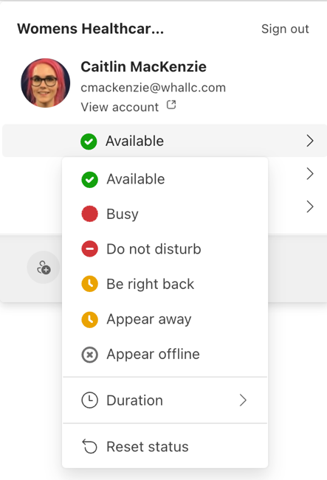
Change Your Availability
  - Signal to the other agents when you’re off duty.
- Change your status in Teams manually by clicking your face in the top right corner. If you are in a status that turns your bubble red or orange, you will not receive calls from a call queue. You will still receive personal teams calls (someone calling you directly) unless you are in Do Not Disturb.
- Under Agents, select the toggle next to your name to remove yourself from the list.
Note: Currently it may take up to two minutes for the other agents to see the change
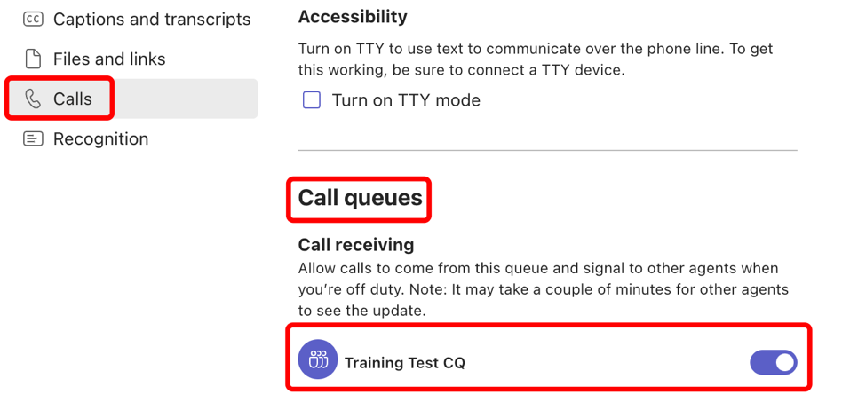
- Go to Settings > Calls and scroll to Call queues to see a list of your queues. Click the toggle switch next to each queue to turn notifications on or off.
Classic Teams (Left)
New Teams (Below)
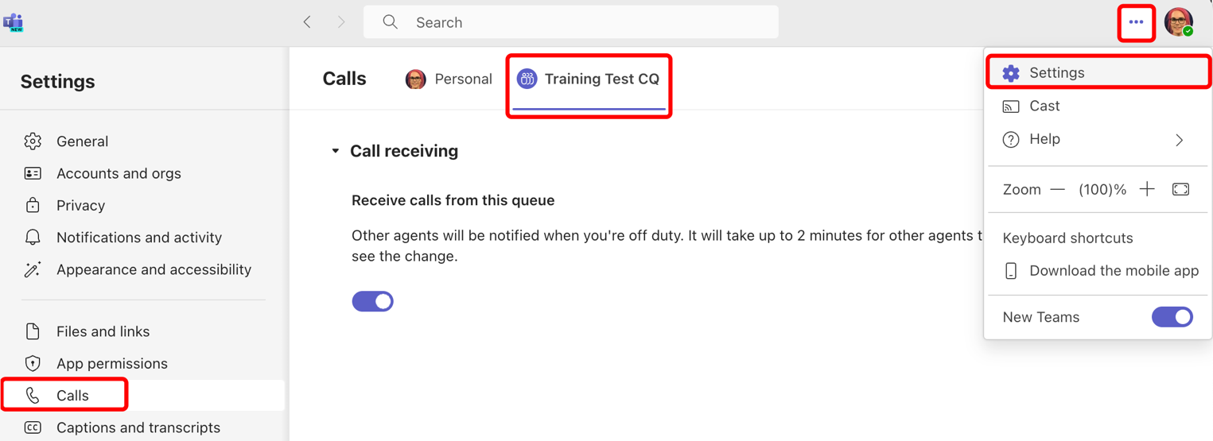

Voicemails
  - Voicemails can be left on a personal line or in some call queues.

Settings
To change your voicemail settings, select Settings and more next to your profile picture at the top of Teams and then choose Settings > Calls .
You will find all voicemail settings under Manage voicemail.

Voicemail greeting
- To record a new voicemail greeting, select Record a greeting and follow the instructions to record your message.

Default greeting language
- Change your default greeting language by selecting the language you want under Greeting language.

Text-to-speech voicemail greeting
- To use a text-to-speech voicemail greeting, type one in Your custom greeting under Text-to-speech customized greeting.
  - Note: If you've recorded a greeting, it'll override the text-to-speech option.
- Out of office voicemail greeting
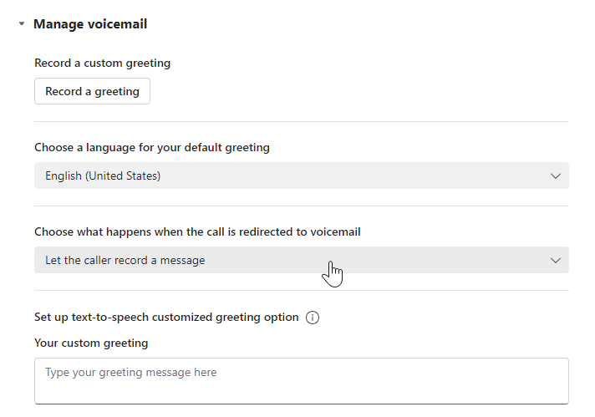
- Type your out of office greeting in Your custom out of office greeting under Text-to-speech customized greeting, then choose when you'd like it to play under Out of office greeting.

Set your call answering rules
- To set your call answering rules, select Settings and more next to your profile picture at the top of Teams and then choose Settings > Calls.
- Choose how you want Teams to handle your incoming calls in the section for Call handling and forwarding.

Personal
To access your voicemail, go to Calls > History and then select Voicemail.
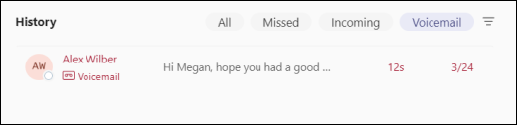
- Call someone back by hovering over a voicemail and selecting Call or by selecting More actions and choosing Call back .
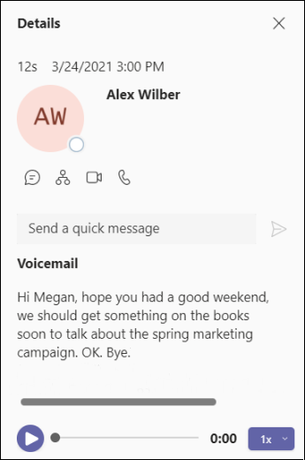
- When you select a voicemail, you can review and access details and other information—all on the right side of Teams.
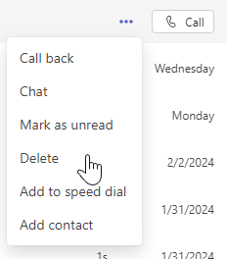
- You can also add the caller to your contacts, call them back, or delete it by clicking the .

Call Queues
  - Some Call Queues have their own voicemail line. The voicemails will show up in both Teams and Outlook.
The status of voicemails is specific to individuals and NOT CQs. This means that if you have listened to a VM it will stay bolded for other agents in the queue, implying that it is unheard. This is true for both Teams and Outlook.
Voicemails left on the CQs will show up in two different places.

Teams
While in the Calls activity of the CQ channel you are able to see call history including any voicemails that have been left. You can also listen to your VMs right in the teams app. You are unable to delete VMs from here (unless you are a team owner) so we suggest using Outlook for all VM management. 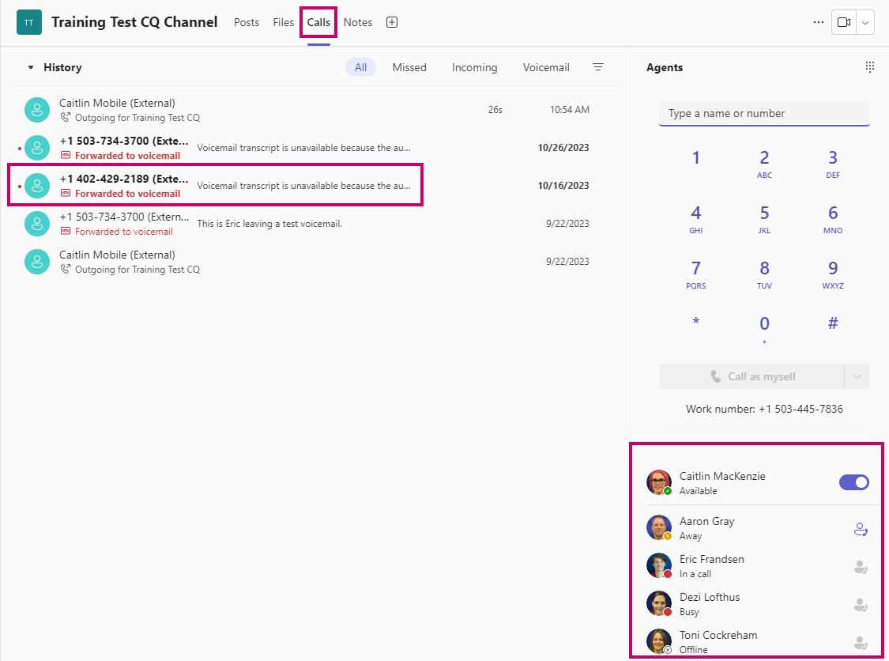

Outlook
All Call Queues that you are a member of will show up on the left-hand side of Outlook.
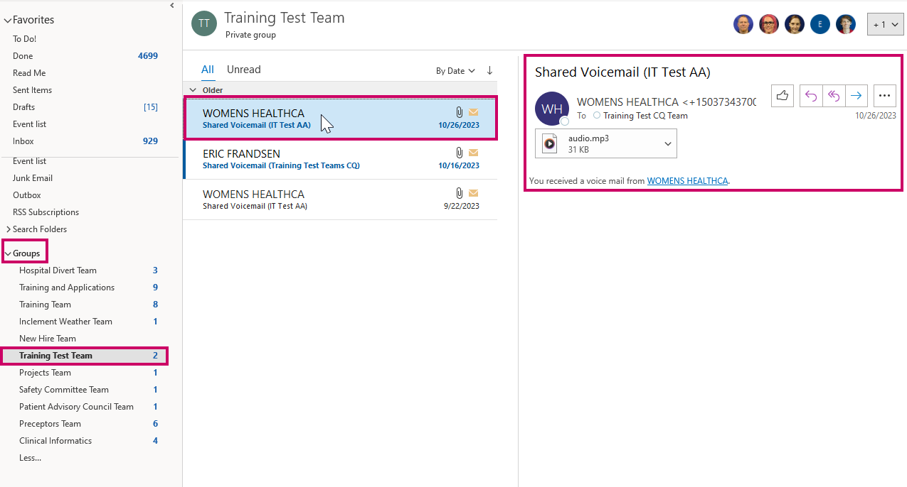
- All Voice Mails will appear in the inbox folder for the Call Queue.
- After listening to the voicemail, the status will change to indicate that it has been heard. Again, this status change is individual specific and will not update for other agents in the queue.

Suggested Voicemail Management Workflow
- When the VM is no longer needed, you can delete it from the inbox in Outlook.
  - This approach will avoid having a lot of back and forth between agents and calling patients more than once.
- If a voicemail gets deleted before intended, please call the helpdesk.

